**DAILY ONLINE ACTIVITIES SUMMARY**

|  |  |  |  |  |  |  |  |  |
| --- | --- | --- | --- | --- | --- | --- | --- | --- |
| **Date:** | **20-05-2020** | | | | | **Name:** | **Sinchana** | |
| **Sem & Sec** | **6 B** | | | | | **USN:** | **4AL17CS117** | |
| **Online Test Summary** | | | | | | | | |
| **Subject** | | **SSCD** | | | | | | |
| **Max. Marks** | | **30** | | **Score** | | | **25** | |
| **Certification Course Summary** | | | | | | | | |
| **Course** | **Python for Machine Learning** | | | | | | | |
| **Certificate Provider** | | | **Greatlearning academy** | | **Duration** | | | **5.0 hours** |
| **Coding Challenges** | | | | | | | | |
| **Problem Statement: 1. Reverse of linked list. 2.Result Set Column 3.Exchange of values 4. Reverse of number 5.Diffie Hellman** | | | | | | | | |
| **Status: Success** | | | | | | | | |
| **Uploaded the report in Github** | | | | | **Yes** | | | |
| **If yes Repository name** | | | | | **coding** | | | |
| **Uploaded the report in slack** | | | | | **Yes** | | | |

Online Test Details: (Attach the snapshot and briefly write the report for the same)

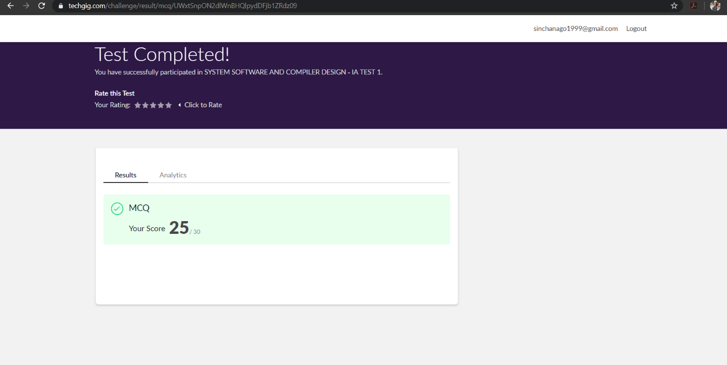

The test was held between 9:15 am to 9:55 am. It consisted of only 1 round and the total marks assigned was 30.The above snapshot is the output of my 1st IA test.

Certification Course Details: (Attach the snapshot and briefly write the report for the same)

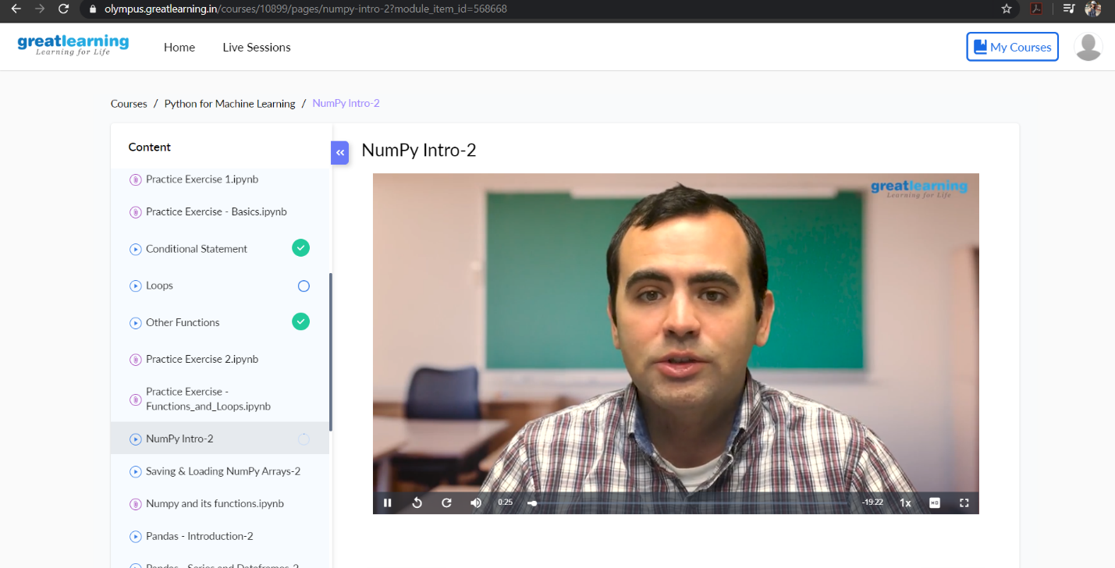

Online Certification Course Summary: Today I have continued with the course and learnt about Anaconda installation and about jupyter notebooks. Anaconda is available free of coast and it is having two versions at present one is 2.7 and the other is 3.7.I have also downloaded Anaconda 3.7 version in my PC. It is one of the platform to Execute python programs and we will also find different IDE’s in Anaconda. In Anaconda command prompt if we write conda list were conda is the basic keyword then we will get list of items which are installed for python. It is shown in the below snap shots.

Coding Challenges Details: (Attach the snapshot and briefly write the report for the same)

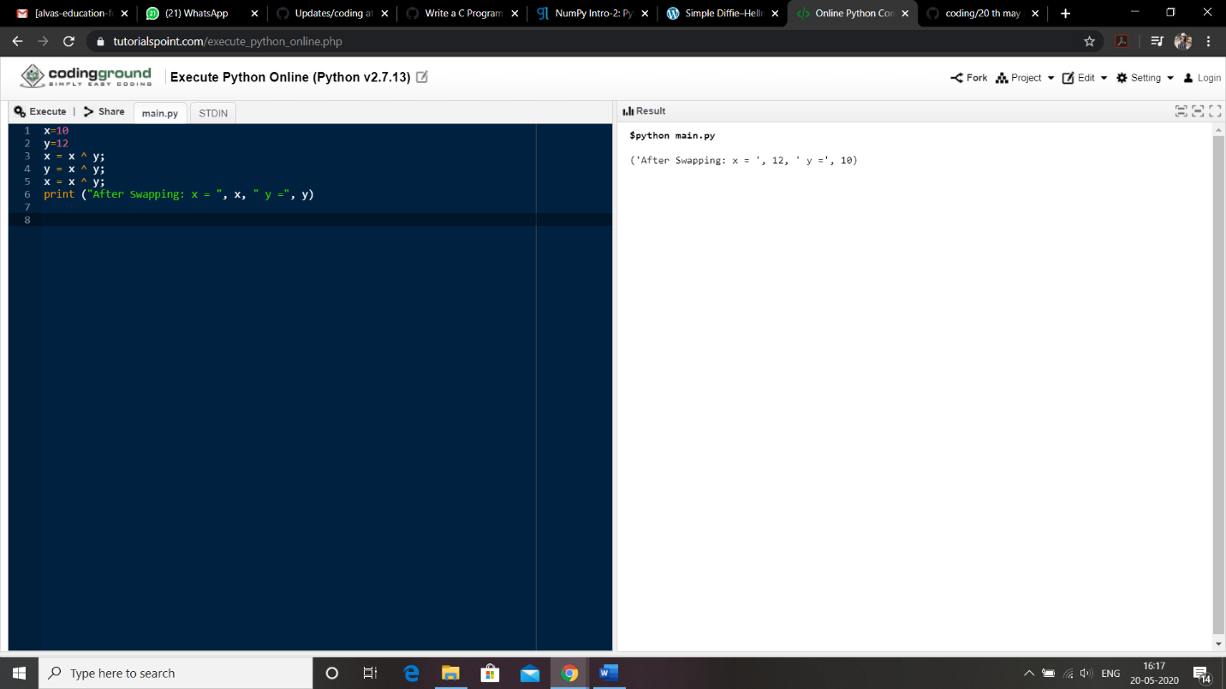

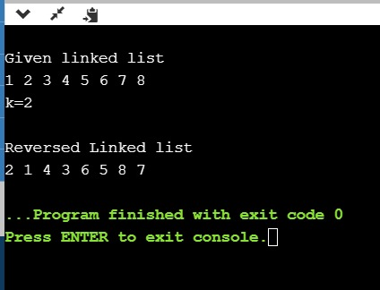

Link in GitHub : <https://github.com/sinchana514/coding>

<https://github.com/sinchana514/coding/tree/master/20%20th%20may>